National Network for Equitable Library Service Braille Project

Thank you for hosting and/or borrowing books from the National Network for Equitable Library Service (NNELS) physical braille collection. Since physical braille in the public library isn’t common, we have prepared some tips and tricks to help you on your journey.

What to Expect When You’re Expecting Braille
Braille is a tactile reading and writing system of raised dots that can be read with the fingers of people who are blind or who have low vision. It is based on a six-dot cell with two columns (from top down, left to right: dots 1, 2, 3, and 4, 5, 6).
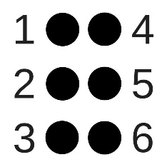
In 2010, Canada adopted the Unified English Braille (UEB) code. This reason for the creation and adoption of this code was to unite the English-speaking countries to use the same braille code. The NNELS digital braille collection has titles in both the Unified English Braille (UEB) code and the English Braille American Edition (EBAE) code. EBAE is often referred to as “old code”. All the NNELS physical braille titles are in UEB. There is also a Unified French code (CBFU) that is used by French speakers who know French braille. In instances where English speakers wish to read braille in French (often the case for French Immersion, Core French programs, and university classes), the braille is still transcribed in UEB, but includes French diacritics.
Braille can be uncontracted (grade 1) or contracted (grade 2). Uncontracted braille is letter for letter or character for character, and contracted braille consists of short forms or contractions that are kind of like writing in shorthand. Most braille is in contracted or grade 2 braille. Appendix 1 contains a simple braille guide that includes the alphabet, numbers, and some of the basic contractions and short forms. For a full braille “cheat sheet”, check out: http://www.pdrib.com/downloads/Complete-Braille-Chart.pdf. This guide will help you identify pagination and other necessary title information. A sample title page can be found in Appendix 2. A sample braille page in a novel can be found in Appendix 3.
One of the most surprising things about braille is how much space it takes up. A single regular print title on the shelf can often be multiple volumes of braille. Novels can often be three or more volumes, and textbooks can often be 30 or 40 volumes. It is very important to make sure that patrons are receiving all the volumes of their title so they can read the entire book.
Braille volumes can be printed as single-sided braille with braille only on one side of each page, or it can be printed as double-sided or interpoint braille. While interpoint takes up less space, it is difficult for sighted individuals to read. Single-sided braille is used most often in K-12 education settings or in early readers’ books where a parent, teacher, or education assistant may be involved in the reading.
Some children’s books are in both regular print and braille, commonly referred to as braille print books, print-braille, or the trademarked term Twin Vision™. These books are great because almost anyone can read them! To see some of these books, you can search your provincial library catalogue and request any of the titles listed on this page: https://nnels.ca/printbraille.
A typical volume of braille is approximately 11.5x11.5 and of varying thickness. Most resource centres who have a lot of braille use shelving that is 12X12 for their braille collections. This allows for the braille to rest on the shelves safely.

The Care and Keeping of Braille
Thank you for being willing to look after these books! We are co-guardians of this collection. Please stamp the volumes with your library’s ownership stamp, add them to your collection, and treat them with the care and love you treat your own books. Should the books become damaged, please don’t charge anyone for the replacement cost: let us know and we’ll decide how to fix or replace them.
The USB stick that was included with the braille contains MARC files for the titles that your library received. Please import these MARC files into your library’s catalogue so that people can search for these books.
When processing braille for your library, extra care should be made when applying ownership stamps, barcodes, and shelf labels. Ensure that labels and tape do not cover any braille, or it won’t be able to be read. When stamping, do not stamp on top of any braille to avoid risk of flattening the braille dots which will inhibit the reading experience. As illustrated below, you can open the braille book up and lay it flat to avoid stamping on braille.
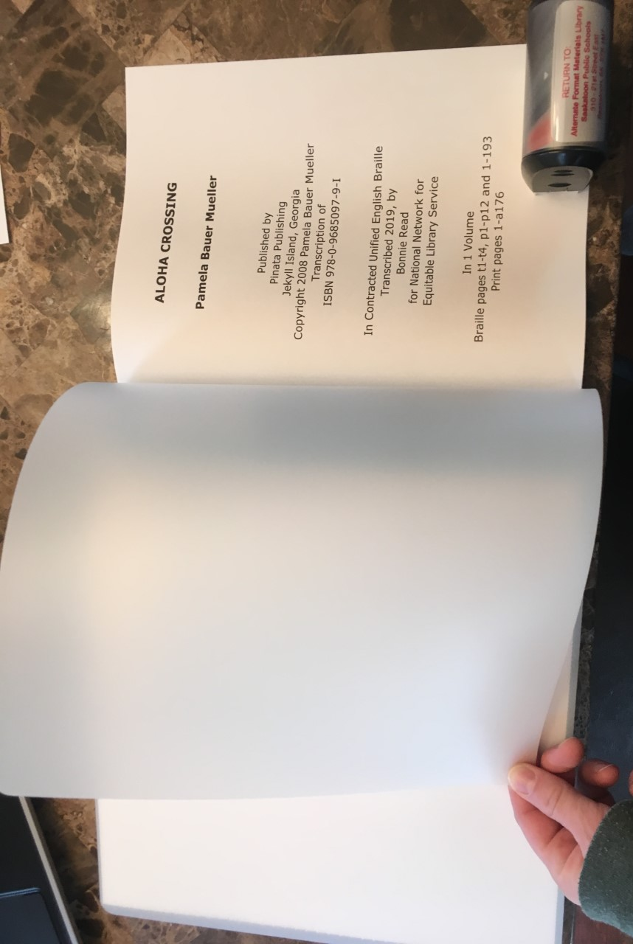
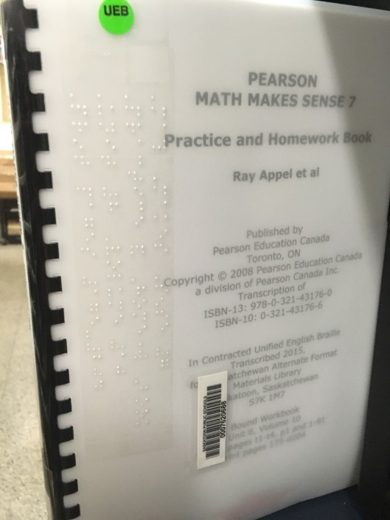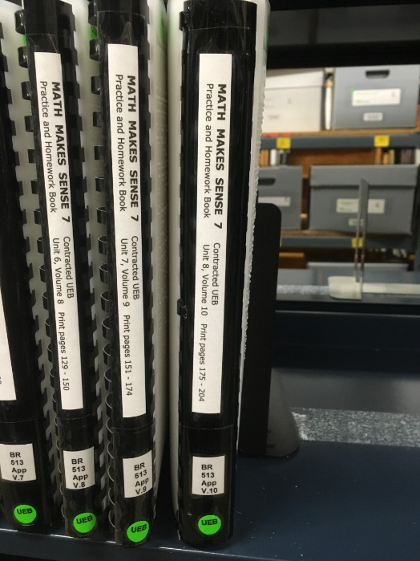
Like all books, braille should be stored in a dry place away from water. Braille should also be stored standing upright using bookends at the end of each shelf to keep them tight, but not crammed to avoid warping or squishing of the braille dots. Over time, if braille is stored flat, the weight of itself can depress the braille dots. Therefore, braille should not be stored stacked or with other items on top of it.
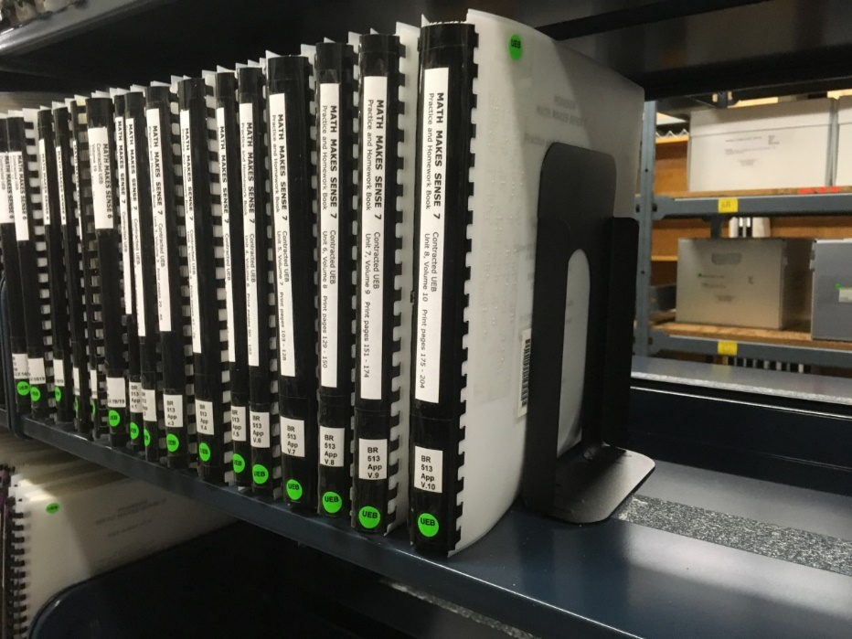
If books become damaged, repairs with tape glue, or hot glue should be avoided. Tape can cover necessary braille and glue can distort or change the braille. Hot glue, especially when used on tactile graphics, can melt the braille/tactile. The best method for repair is to contact NNELS by emailing braille@nnels.ca so they can arrange for replacement pages.

Sharing with Others
It is the hope of NNELS that these braille titles will have the opportunity to travel to other communities in your province and all over Canada.
Like storing braille on a shelf, when possible, braille should also be shipped standing up when shipping multiple volumes. It is recommended to ship braille in boxes rather than fabric or bubble envelopes. If the box is not full, packing paper or foam can be used to ensure the braille doesn’t move around and cause warping during transit. Try to avoid using newsprint as packaging paper because it gets the braille all inky.
According to the Canada Post Guidelines found in Appendix 4, braille can be shipped free of charge with Canada Post. This will allow for libraries to share braille across Canada without having to pay for postage. If the post office in your community hasn’t dealt with braille before, it may not be familiar with this provision. If this happens, you can ask to review the “Literature for the Blind” section of their manual with them. In Appendix 5, you will find a sample post-free label.
NNELS recommends using your existing loan period for the length of loan for braille titles, excluding shipping time.

Help! We Need a Title!
Find more books in this hardcopy collection by visiting nnels.ca/braille/. You will also find electronic braille files which can be read with a refreshable braille display or notetaker, as well as the braille print titles we mentioned earlier.
If your library is interested in purchasing your own braille titles, consider the economical options found in Appendix 6.
Braille, and other alternate formats are also available to students in all the provinces and territories across Canada. Most of these providers of educational materials in alternate formats belong to a group called the Canadian Association of Educational Resource Centres for Alternate Format Materials (CAER). Visit https://caercanada.ca/ to find out more information and to view contact information for each resource centre.
If you are not currently a hosting library, but would like to be, or if you are currently a hosting library and would like to stop, please let us know. If you have any other questions or feedback, please contact us:
- Call: 1.888.848.9250, option 5
- Email: braille@nnels.ca
- Website: http://www.nnels.ca

Appendix 1
ALPHABETIC wordsigns
a a  b b (but)  c c (can)  d d (do)  e e (every)  f f (from)  g g (go)  h h (have)  i i | j j (just)  k k (knowledge)  l l (like)  m m (more  n n (not)  o o  p p (people)  q q (quite)  r r (rather) | s s (so)  t t (that)  u u (us)  v v (very)  w w (will)  x x (it)  y y (you)  z z (as)
- stand-alone & hyphenated words
- use with: ‘d, ‘s, ‘t, ‘re, ‘ve, ‘ll

STRONG
Contractions | Wordsigns | Groupsigns
& and  = for  ( of  ! the  ) with | * child  % shall  ? this  : which  \ out  / still | * ch  % sh  ? th  : wh  \ ou  / st | > ar  $ ed  ] er  < gh  [ ow  + ing
whole/part words spaced as in print | stand-alone & hyphenated words  ‘d, ‘s, ‘t, ‘re, ‘ve, ‘ll | - where letters occur  - “ing” can’t begin words

NUMERIC MODE
#a 1  #b 2  #c 3  #d 4 | #e 5  #f 6  #g 7 | #h 8  #i 9  #j 0

PUNCTUATION & SYMBOLS
4 . (period/full stop)  1 , (comma)  ' ‘ (apostrophe)  2 ; (semi-colon)  3 : (colon)  - - (hyphen)  8 ? (question mark) | 6 ! (exclamation point)  @& & (ampersand)  @a @ (address sign)  @s © (copyright symbol)  ^c $ (dollar sign)  "< "> ( ) (round parentheses)

Appendix 2
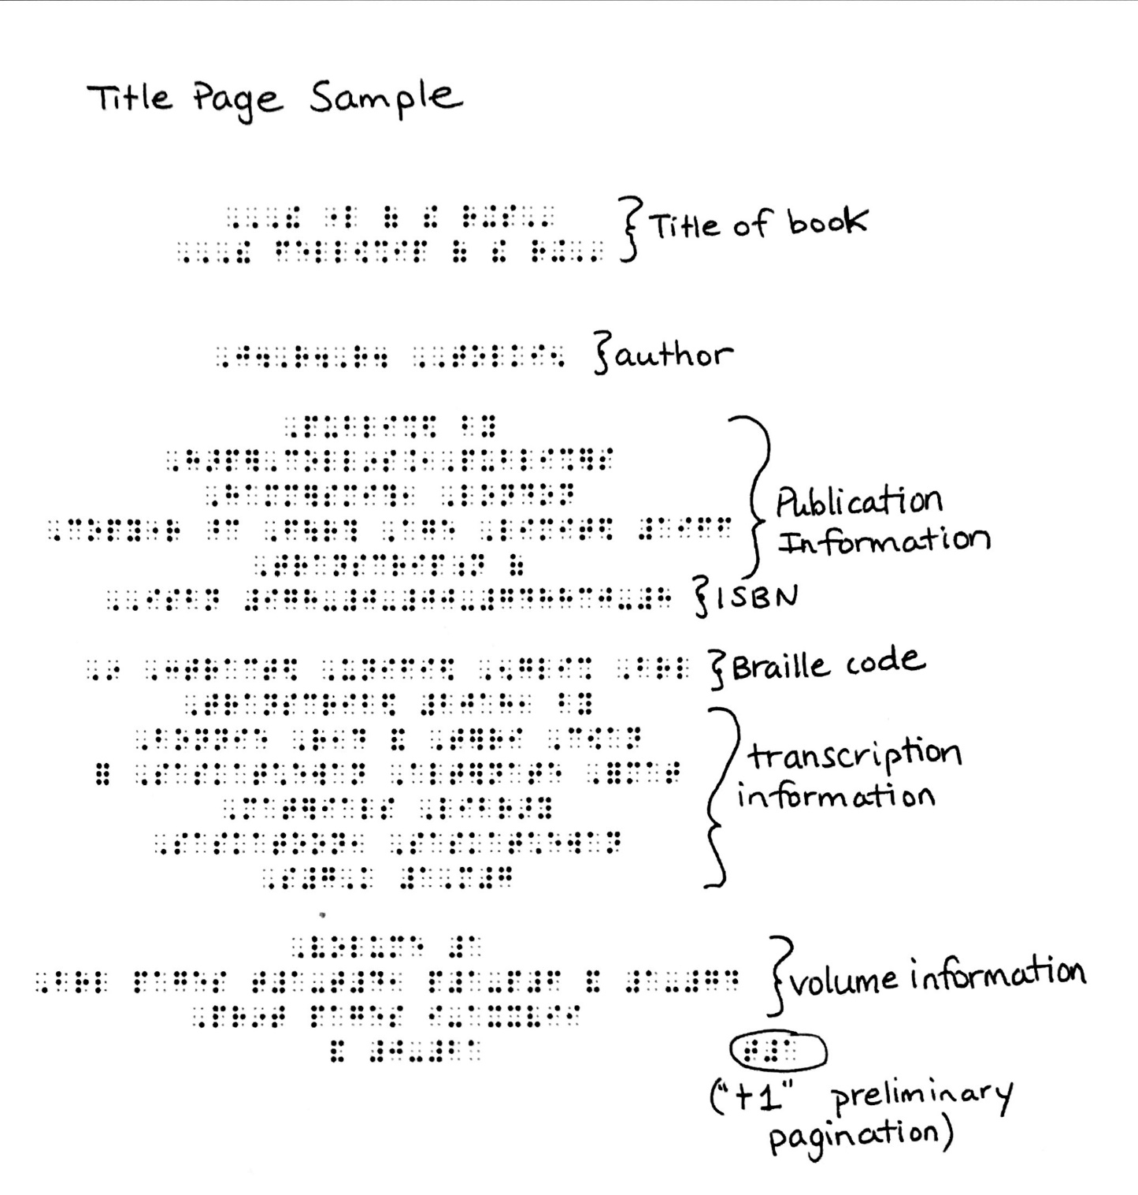

Appendix 3
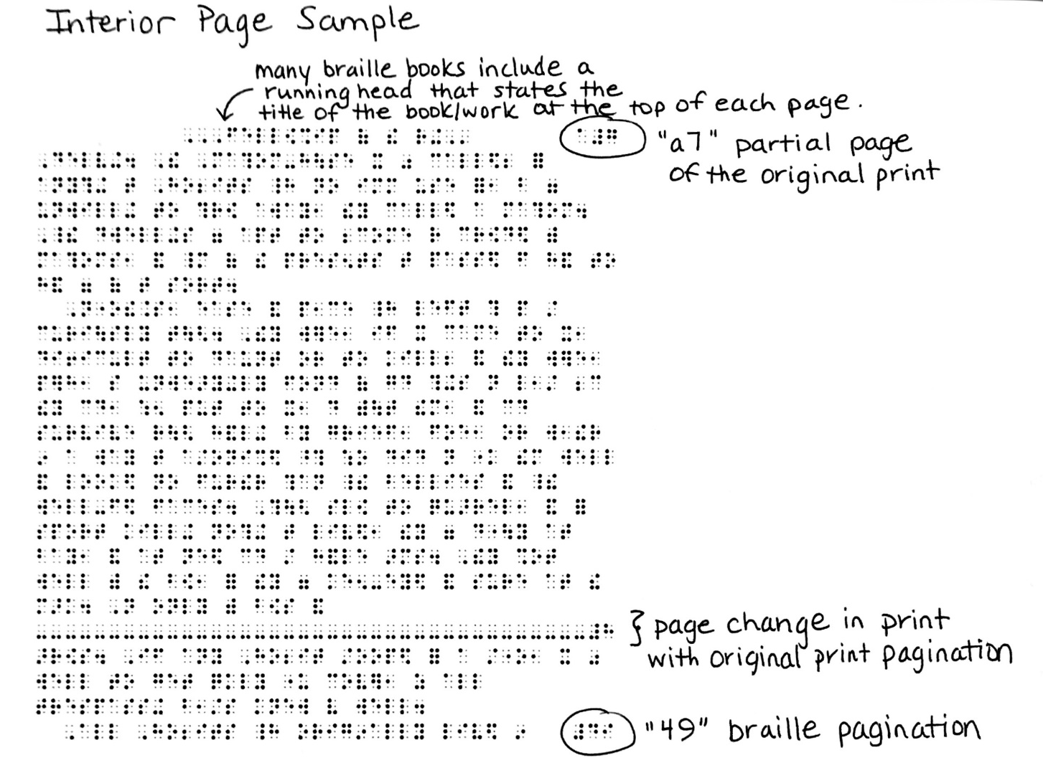

Appendix 4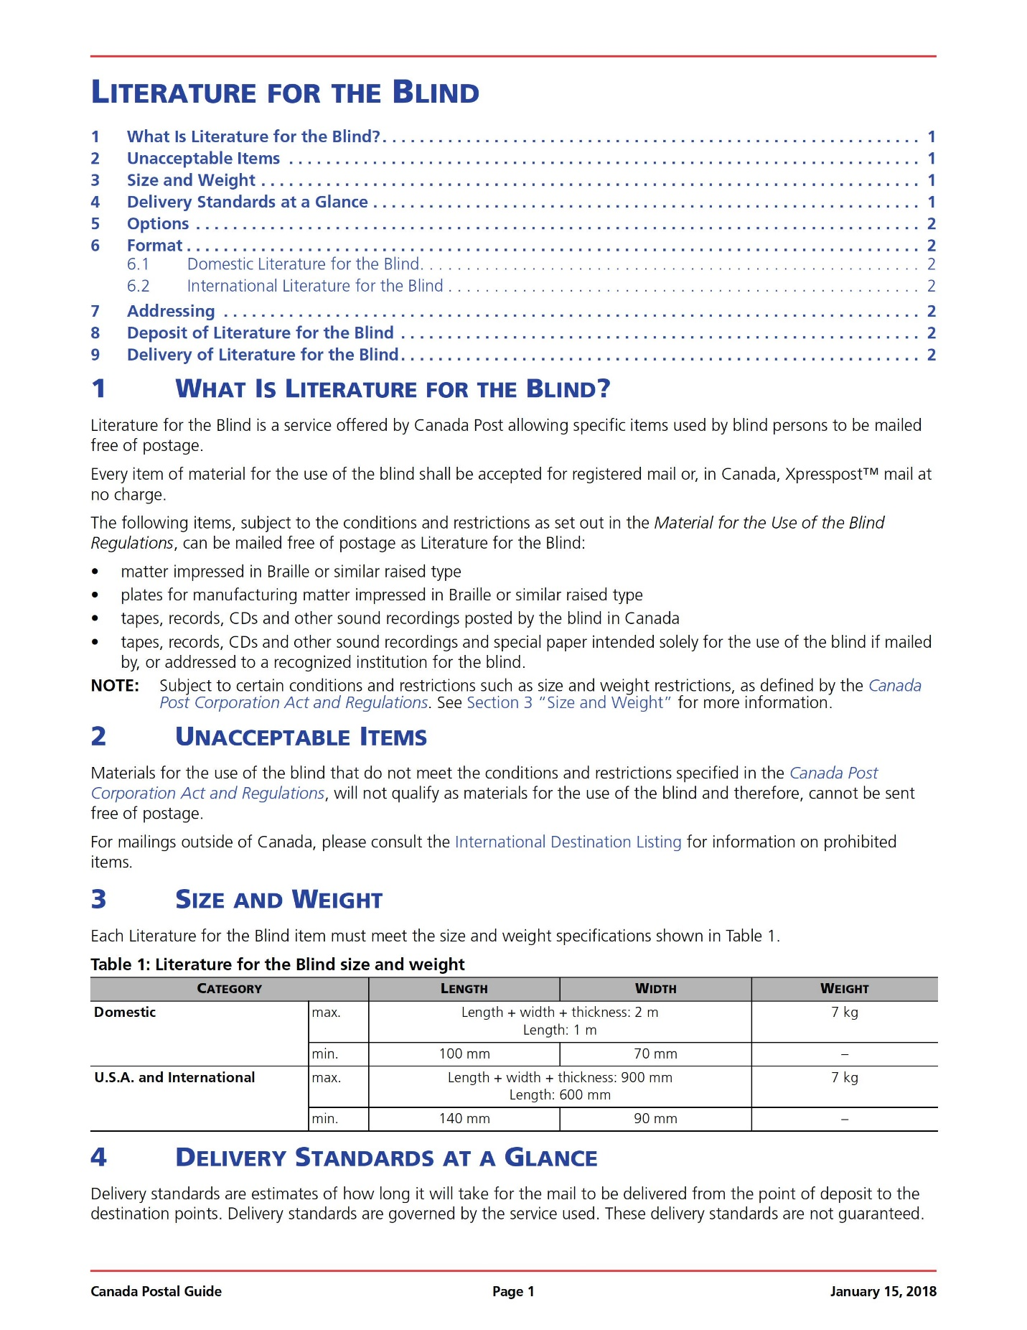
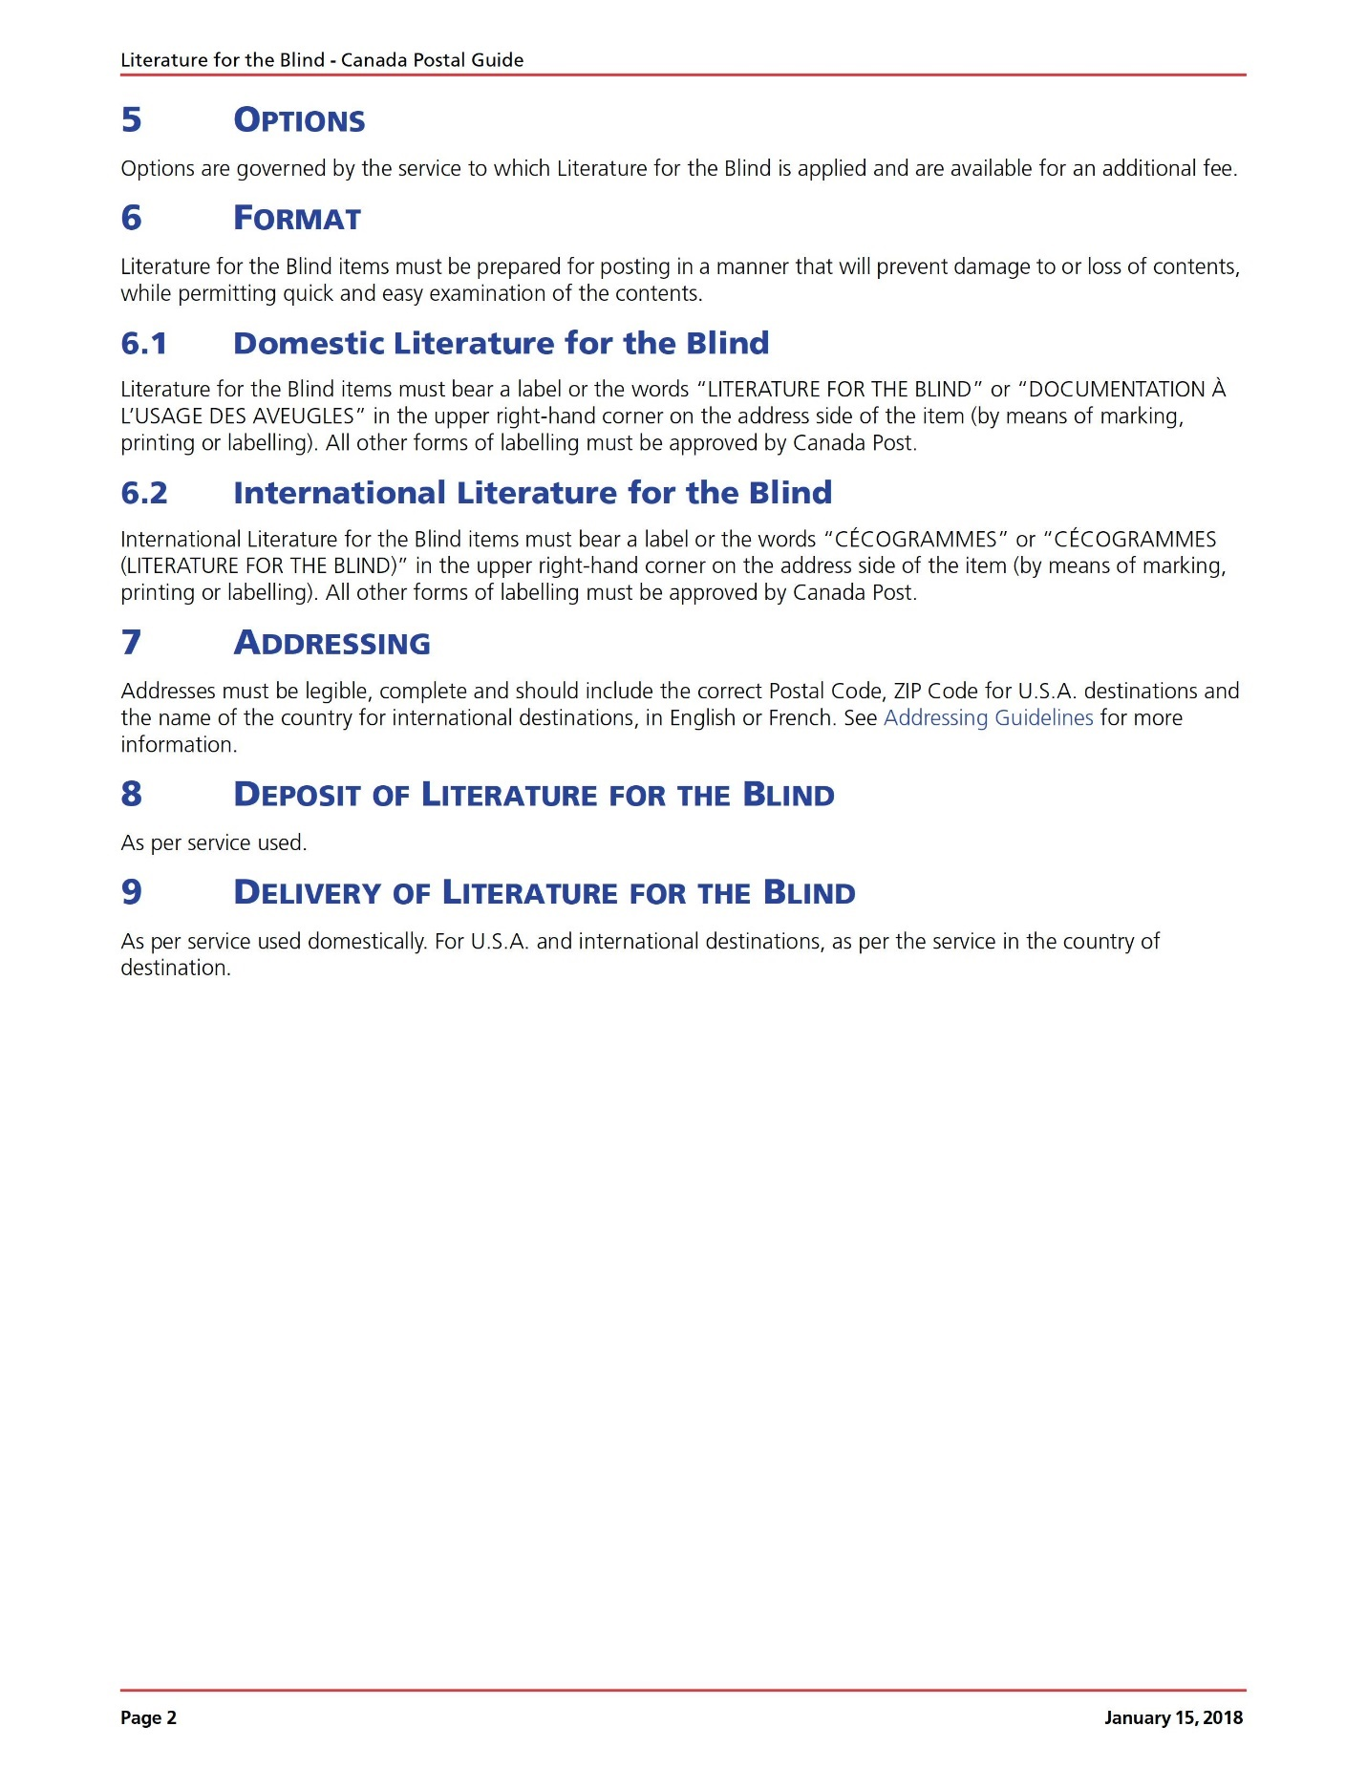

Appendix 5
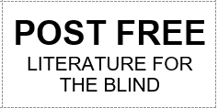
Postage free labels on U-LINE S-3847Y
You can always make your own labels on whatever stock/label sheets you like the best.

Appendix 6
- American Printing House for the Blind
https://www.aph.org
1839 Frankfort Avenue
Louisville, Kentucky, USA
1.800.223.1839

- Braille Superstore (books are not suitable for library-use)
http://www.braillebookstore.com/Braille-Bookstore
33222 Lynn Avenue
Abbotsford, British Columbia, Canada
1.800.987.1231

- National Braille Press
www.nbp.org
88 St. Stephen Street
Boston, Massachusetts, USA
1.617.266.6160

- Seedlings Braille Books for Children
www.seedlings.org
P.O. Box 51924
Livonia, Michigan, USA
1.800.777.8552

- Tactile Vision Graphics
https://tactilevisiongraphics.com
400 Erie Street East, Unit 9
Windsor, Ontario, Canada
1.866.465.0755

